Connected to Jesus - Jesus the Vine

Did you know that when we are part of God’s family we are all connected? Jesus had a great way to explain it. He said: “I am the vine and you are the branches...”
Read or listen to John chapter 15 verses 1-8
A vine is a plant. It has a long stem running up the middle and lots of branches growing off from the stem. Healthy vines grow lots of fruit! Have you ever seen a vine with lots of fruit? Normally vines grow sweet, juicy grapes. I wonder why Jesus said he was a vine and his followers are the branches?

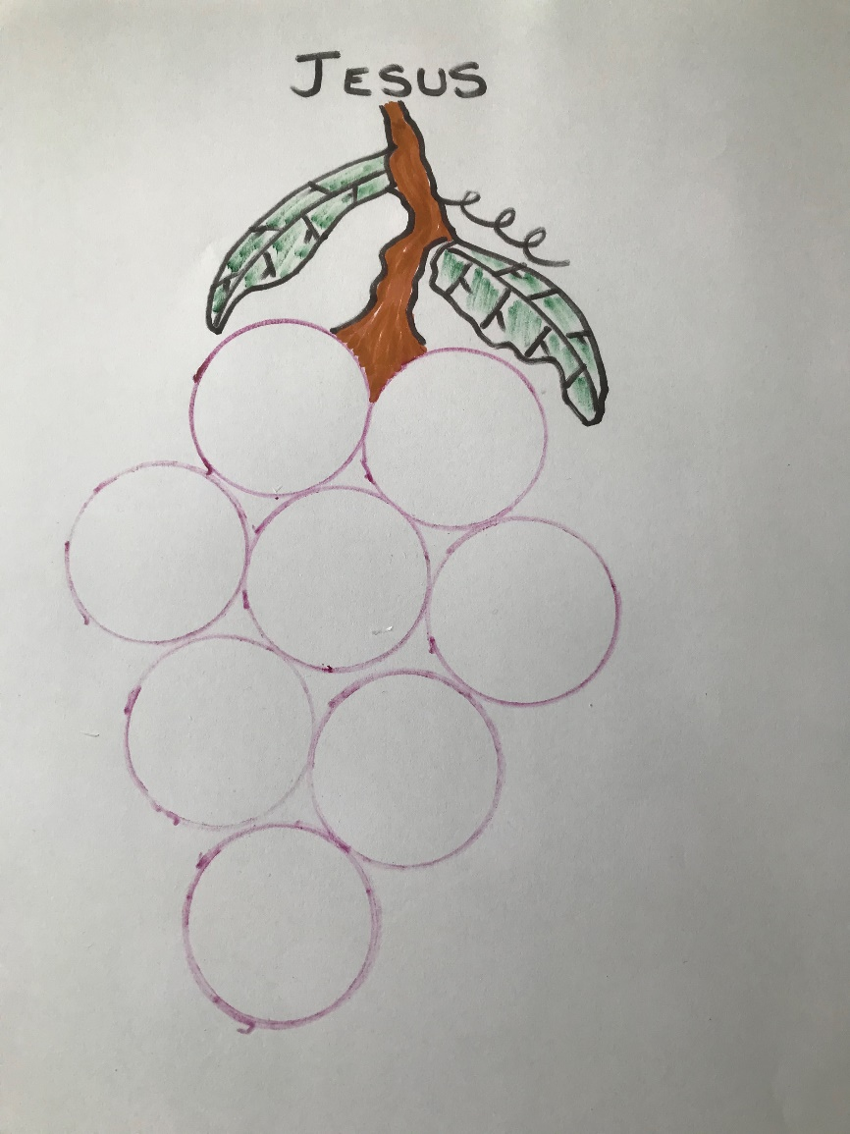

Those who follow Jesus need to stay connected to him and get all their strength and help from him by trusting in him.
He has a special job for us to do so we can produce ‘fruit’ (good values and good work) for him

Activity: Write some 'good fruit' ideas in the grapes.

For ideas go to the bible and read or listen to Galatians chapter 5 verses 22-23
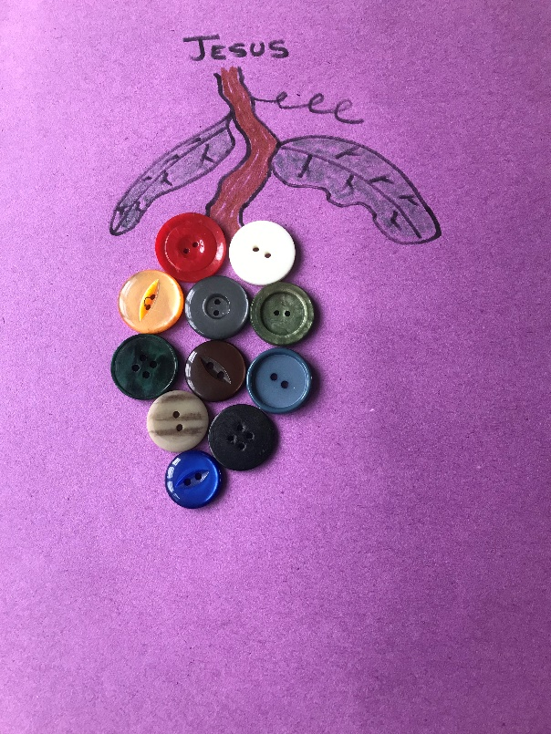
Activity: Draw a branch then collect buttons and glue them onto the branch as 'grapes'

Colour code your buttons to represent 'good fruit'
For example: red is love

When you have finished see if you can remember the code without looking

By being connected to Jesus we also become connected to each other like branches on a stem or a tree trunk. Jesus told his disciples to love one another.
Jesus wants more people to be connected to him.

Activity: Think of ways we can stay connected to Jesus and help our friends to get closer to Jesus too. Draw up a list of things and share that list with someone you know.

Prayer: Dear Lord Jesus, thank you for teaching us about staying close to you. Please help me to come closer and closer to you. Help me to care more for my friends and family. Most of all help me to bear lots of fruit so that I can be loving, kind, patient and all the things you have made me to be. Amen.

