Practical Prayer - Thankfulness - A 'Thank you' Walk

In Genesis, chapter 1, the first book of the Bible, it says
'and God saw everything that he had made and it was very good'

When you go out for a walk in the countryside, in your garden, in your street with your family or household take this list with you.
Look out for:
Something that makes you happy
Something bright and colourful
Something you can touch safely
Something in your favourite colour
Something that took a long time to grow
Something you or an adult can take a photo of or draw when you get back home

Here are some ideas:
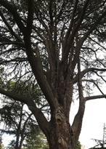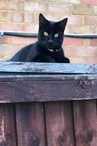

As you tick off the list of things say 'thank you' to God for them.

Try to say 'thank you' 20 times today for things you do not often say 'thank you' for.
How does it make you feel?

If you cannot get outside for a walk use the pictures above and pictures in a book to choose things to complete your list

